TIDAL ENERGY

Tidal energy was explored for use on the Island of Great Cumbrae. Various aspects of the technology and resource were investigated, including the availability of the resource on the region & Island, the environmental problems associated with deploying the technology, planning & leasing requirements, health & safety concerns and finally, the existing government policy support framework available.

Tidal energy is primarily caused by the gravitational forces of the sun and moon acting upon the earth and its oceans as these planetary bodies rotate around each other. The various orbital cycles which determine relative ocean movements and heights are as follows:

1. The daily or half cycle associated with the rotational movement of the moon around the earth.
2. The global 29.5-day cycle associated with degrees of alignment of the sun and moon resulting in ‘Spring’ & ‘Neap’ tides and,
3. The half year cycle associated with the alignment of the moons orbit with Earth’s (Sustainable Development Commission, 2007)

A 2012 study carried out by the Crown Estate estimated the marine energy potential available in the UK. Studies show a great potential exists for exploiting tidal energy in the UK, with total energy estimates from all tidal based technologies estimated at 216 TWh/year. A large proportion of this resource exists in Scottish waters, with preliminary estimates suggesting an indicated maximum power generation capacity of 23.5 GW from all types of tidal technologies.

|  |  |  |  |  |  |
| --- | --- | --- | --- | --- | --- |
|  | **Type** |  | **Location** | **Indicative annual energy** | **Indicative maximum** |
|  |  |  |  | **[TWh/year]** | **power [GW]** |
|  |  |  | England | 34 | 11 |
|  |  |  | Wales | 28 | 9.5 |
|  | Tidal stream |  | Scotland | 32 | 11 |
|  |  |  | Northern Ireland | 1 | 0.5 |
|  |  |  | Total | 95 | 32 |
|  |  |  | England | 57 | 27 |
|  | Tidal range: barrage |  | Wales | 23 | 8 |
|  | schemes |  | Scotland | 16 | 10 |
|  |  |  | Total | 96 | 45 |
|  |  |  | England | 14 | 8 |
|  | Tidal range: lagoon |  | Wales | 7 | 3.5 |
|  | schemes |  | Scotland | 4 | 2.5 |
|  |  |  | Total | 25 | 14 |

Source: (The Crown Estate, 2012)

To date, the Crown Estate which is responsible for granting leasing areas on the UK seabed has leased 30 UK tidal stream sites, 17 of which are located in Scotland, 9 of which are located further north of Scotland which is projected to have the largest tidal energy potential (Neill, et al., 2017).

Types of Tidal Energy Technologies

Tidal energy can be harnessed in a number of configurations. They falls broadly into two main categories namely:

1. Tidal Steam Energy: This comprises energy associated with tide ebbs and floods which manifests itself as a tidal current. Tidal steam devices extract energy from this current to produce electricity.
2. Tidal Range Technologies: these devices ‘capture’ the incoming water from the rising tide in artificial lagoons or barrages. Turbines located within the barrage or lagoon capture energy as the tide floods back into the reservoir (Hinson, 2018)

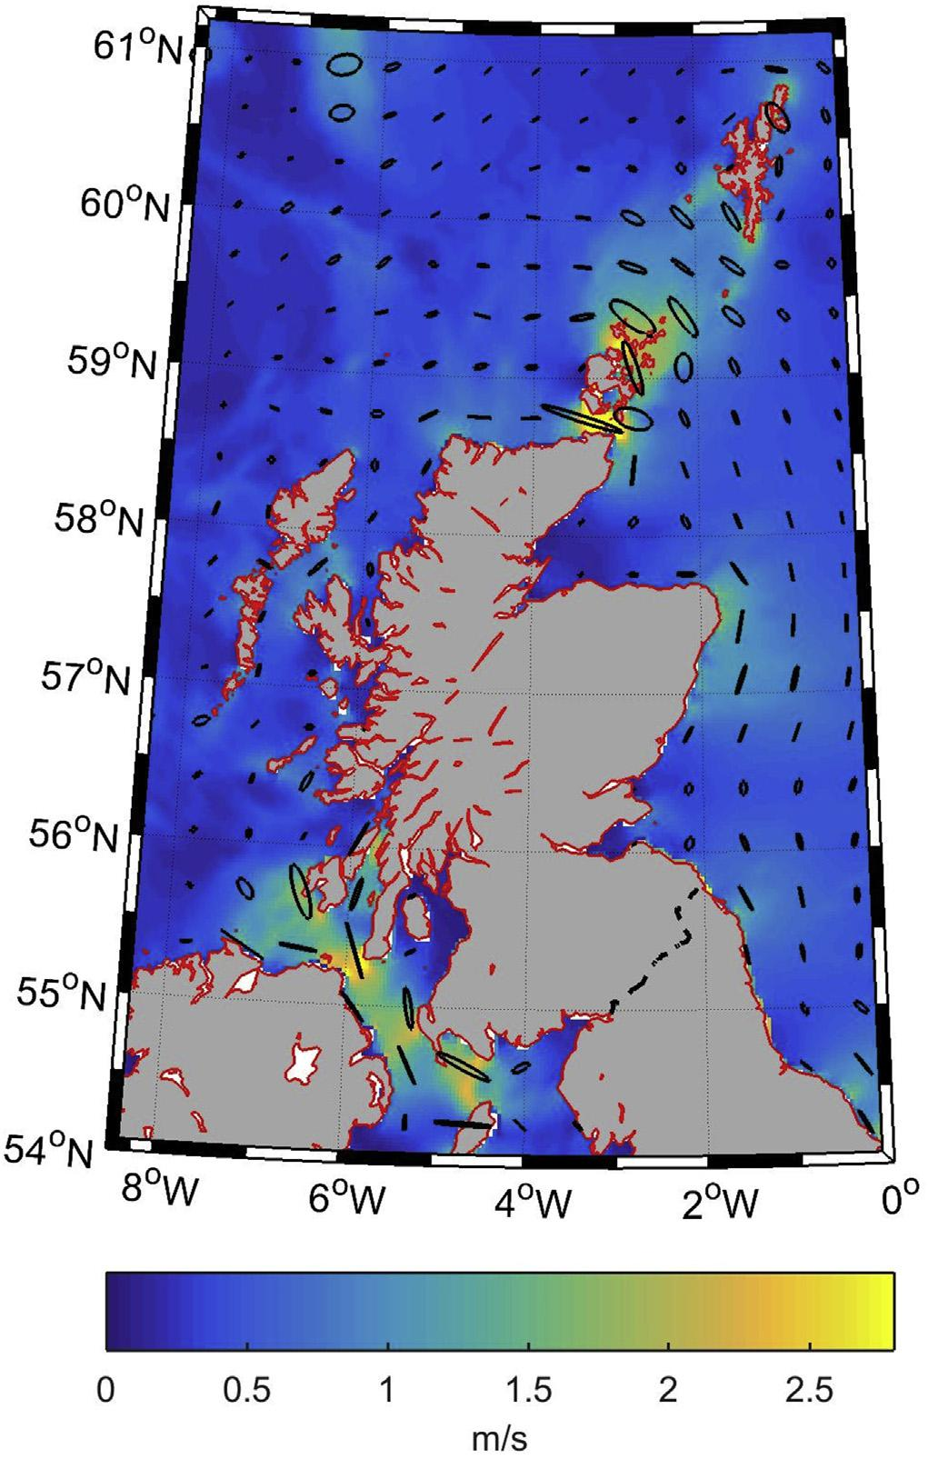

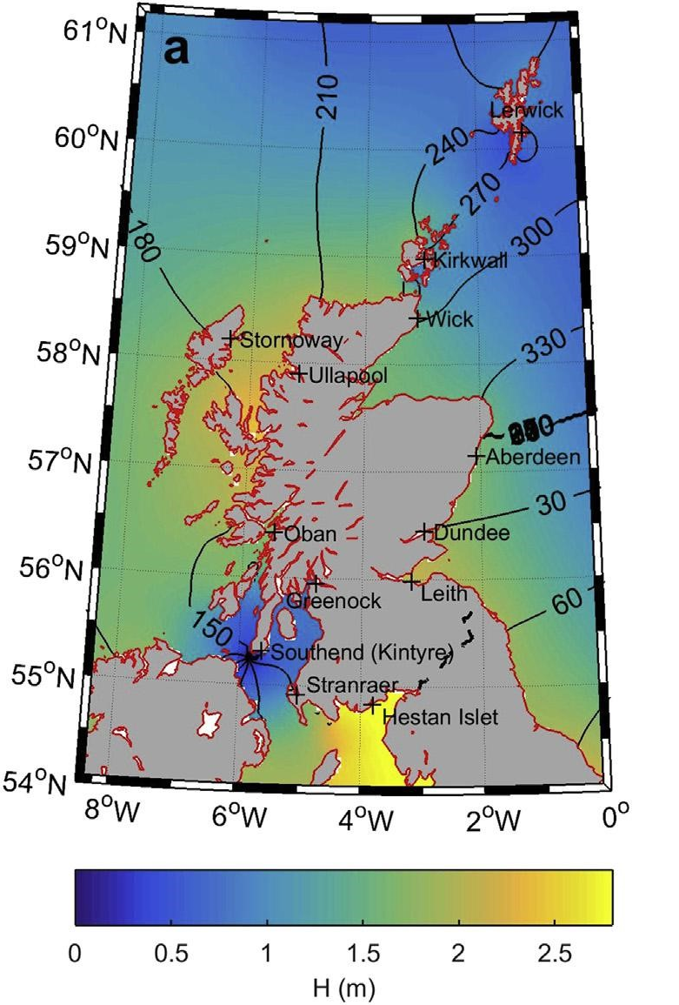Figure (a) (left) & Figure (b) (right) depicting the tidal stream and tidal range energy potential in Scottish Waters. Source: (Neill, et al., 2017).

Figure (a) above indicates the distribution of tidal stream currents around the Scottish seaboard. The highest potential for tidal stream technologies exist in the North of Scotland in areas around the Pentland Firth region, Orkney & Shetland. Tidal stream currents in these areas frequently exceed 2.5 m/s. In the areas around the Island of Great Cumbrae (highlighted with a small rectangle), tidal stream currents rarely exceed 1m/s. Since power generated is a function of the velocity cubed, the tidal stream resource available in the North of Scotland far exceeds that available on the Island of Great Cumbrae. Similarly, figure (b) above highlights the tidal range potential around Scottish waters. The mean spring tidal range in Scotland typically ranges from 3-4 m but exceeds 7 m in the Solway Firth (Neill, et al., 2017). The greater potentials for extracting energy from tidal range are highlighted in yellow on these maps. As can be clearly seen on these maps, the Island of Great Cumbrae has very limited potential to harness energy from tidal range technologies as well. Most of this resource is similarly concentrated further north of the region.

Economic & Financial Issues

The economic viability of tidal energy resource exploitation is contingent on the power density of the resource available in the area of interest. As demonstrated by figure’s (a) & (b) above, The Island of Great Cumbrae is situated in an area of low energy densities, with tidal stream velocities reaching only 1 m/s. From past research and investment attempts, this stream velocity is not considered economically viable for tidal stream conversion (Neill, et al., 2017). Also as evidenced by similarly ongoing tidal range projects like that being considered on the Severn Estuary, the capital costs of these projects run into the millions with that of the Cardiff-Weston barrage proposal on the Severn Estuary estimated at £ 15.066 million. This alongside the long construction times (7 years in the case of the Cardiff-Weston Scheme) and long delay before revenue generation accrues large interest payments even before the project can break even. This makes any tidal range project highly capital intensive (Sustainable Development Commission, 2007). A report from the Carbon Trust on the cost competitiveness of tidal stream technologies estimates the tidal stream technologies to have cost of energies between 9p/KWh and 18p/KWh, costs which are much higher than conventional power and renewable power generation prices.

Environmental Challenges

Significant concerns have been raised about the environmental issues surrounding tidal energy exploitation. Interest groups such as the South & West Wales Wildlife Trust have expressed concerns over the scale of tidal lagoon projects and its potential impact on biodiversity. The Angling Trust and Fish Legal have called for more scrutiny of the potential impact of the lagoon on the marine environment and the migratory fish present in Swansea Bay. Other concerns raised include the potential for non-native species to be introduced as a result of any attempt to build a seawall, the detrimental impact on marine animals due to construction in these water bodies and the impact of migratory fish as they pass through active underwater turbines (Hinson, 2018).

Planning & Leasing Requirements

As mentioned above, the Crown estate is responsible for granting leasing areas on the UK seabed and have granted a number of licenses driven at exploiting tidal resources off UK seaboard (Neill, et al., 2017). The Swansea Bay Tidal Lagoon project being developed by Tidal Lagoon Power (TLP) details typical permissions and agreements to be met before tidal projects are allowed to be undertaken. These include a Development Consent as specified in the 2008 Planning Act, a Marine licence for (i) marine energy works; and (ii) to dredge and dispose of material at sea as contained in the Marine and Coastal Access Act 2009, & a Crown Estate Lease Agreement (Hinson, 2018). Obtaining these licenses can lead to significant delays (up to 3 years) and can hinder project development. Given the desire to implement this renewable energy project on a timely basis, our team strongly recommends tidal exploitation on these grounds as well.

Health & Safety Concerns

Several issues arise from tidal energy technology exploitation. Noise from construction, maintenance & decommissioning can affect local communities. Seabed patterns of sediment erosion, transportation and deposition are also affected by these underwater systems. Water quality can also be significantly affected by the potential leakage of lubricants and hydraulic fluids, thereby affecting the fish fauna in the area (Sustainable Development Commission, 2007). Because of a lack of extensive research data on the subject, exploiting tidal energy may have several negative repercussions for the communities and habitats they play host to.

These issues surrounding the development of tidal energy projects coupled with the low resource density in the Great Cumbrae area have informed our team not to pursue the exploitation of this resource towards the provision of power for the inhabitants of that Island.